**Stability and change in Australian law-making, 1901-2022 (or the rise of the legislative behemoth).**

We argue that over the long run, the stability of Australian legislation has been governed by the properties of the binomial distribution. By stability, we refer to the distribution of changes to legislation in one parliamentary term: some acts experience no change at all, while others may receive many amendments before the next election. Given a fixed number of legislative interventions in a parliamentary term and the number of acts already on the books, we can predict the distribution of changes to Australian law with a high degree of accuracy. Only after the 1970s, a period of intense instability in Australian and international politics, do we see a prolonged deviation from the expected binomial distribution’s variance, also known as overdispersion. We show that this overdispersion is due to two important changes since the 1970s; first an increase (relative to expectation) in the proportion of acts that receive no changes at all (we refer to these as dormant acts); and second, an increase in the proportion (both relative and absolute) of acts which receive a large number of amendments (which we refer to as monster acts). After demonstrating these claims statistically, we provide an illustrative survey of some of these legislative behemoths and discuss their potential impact on the quality of public policy. Finally, we briefly discuss the potential institutional and political causes of these changes to legislative practice.

The binomial distribution is one of the simplest statistical distributions applicable to discrete data, and describes the number of successes in independent, repeated trials of a binary outcome. It has two parameters,  the probability of success, and the number of trials. We use two pieces of summary data from each legislative term to generate theoretical quantities of the binomial distribution: first, the number of acts on the books, and second, the combined number of new acts and amendments over a parliamentary term. To begin with, we define  as approximately , where gives the total number of principal acts existing at the term’s end. This is, of course, an approximation because the number of acts on the statute book fluctuates as the government passes new acts and repeals old ones during the parliamentary term. The likelihood of this probability being precisely accurate at the moment of legislation is vanishingly small. Nevertheless, we will demonstrate that this approximation fits the sample distributions accurately. The second parameter is , the number of independent trials. We define this quantity as the combined number of new principal acts and the number of amendment events, over the course of a parliamentary term. We exclude repeals in this number, as the number of repeals is reflected in the number of acts remaining on the books by the end of the term. In parameterizing enactment events in this way, we are likely to violate the independence assumption inherent to independent trials, since the nature of legislative agenda-setting presupposes that some areas of policy are more likely to receive attention than others. It is very likely that one change begets another, as enacting a piece of legislation in a particular area of law perhaps changes the probability of amendments to other acts that deal with other issues. As we shall see, this is certainly the case for legislative activity after the 1970s, but we see very little evidence for overdispersion before this period.

As a random variable, the data appear as a list of all acts still existing at the end of the parliamentary term, alongside the number of legislative events for that act, excluding repeals. Over  total enactments, the binomial distribution models the probability of making enactments to a specific act as:

with expected value  and variance  In Figure 1, we plot the agreement between our observed data and the binomial distributions generated using the parameters described above. On the left-hand panel, we plot expected values (or the means of our generated distributions). The closeness of the lines demonstrates that our approximation of and our measure of function very well; our generated binomial distributions fit the data with a high degree of accuracy. There is a slight deviation from the expected mean in the first parliamentary term after federation (5 per cent error), after which errors reduce to .

On the right-hand panel, we plot the expected and observed variance. Here, too, we see a very close alignment between the theoretical and observed distributions. Over the 46-parliament study period, the two correlate at . However, we do not see the exact relationship that we see for expected values, as fitness appears to change over time. Therefore, we divide the statistical history of Australian lawmaking into three distinct periods: converging, binomial variance, and overdispersion.

In the converging period 1901-13, the binomial model distribution over-estimates the variance of the observed distribution. The reason for this is simple. In the first four parliamentary terms, the newly created federal government was concerned overwhelmingly with passing fundamental pieces of primary legislation, with very little focus on amendment. This means that by far the most common frequency of enactments for acts in this period is 1, the principal act that brought the act into being. Before 1913, the observed distribution did not fulfil the expected properties of the binomial distribution but instead rapidly converged toward the expected variance over the four-parliament period. By the time of the fifth parliament beginning in May 1913, the expected and observed variances were in clear alignment.

The second period, 1913-1977, exhibits a 64-year period of close fit for both mean and variance to the theoretical binomial distribution, which implies a balance in stability and change for Acts of Parliament. Given the amount of overall legislative activity in a parliamentary term, the distribution of enactment events per act falls naturally. It also implies a degree of independence in law-making from one act to another: intense parliamentary activity on one act did not lead to neglect of other acts. Observational studies in the natural sciences frequently exhibit overdispersion of binomially distributed data. Data on the gender balance of children in large families show that there are more all-girl families, and more all-boy families than one would expect from the binomial distribution, despite strong theoretical reasons to assume that the probability of giving birth to a girl is 0.52 for all women and all births (CITE). Such a close relationship to the binomial distribution in law-making during this period is therefore surprising, since we would expect that the hard time limit on passing legislation before the next federal election leads to prioritization of political and legislative agendas and therefore strong focus on some areas of law to the exclusion of others.

This is, however, precisely what we find in the third period 1977-2022, where the observed data show an increase in the variance above the expected binomial variance. While this overdispersion is apparent to the naked eye, it is important to complement this finding with statistical tests. In Appendix A1, we describe a simulation routine for one-tailed overdispersion tests at the 95% and 99% confidence levels. Our findings demonstrate that overdispersion likely exists at the 95% level in a few isolated time periods since 1901-1975, with all terms since the 30th Parliament (ending in 1977) indicating overdispersion. At the 99% level, no terms before the 32nd Parliament (beginning in 1980) were overdispersed, while legislation in each subsequent term was over-dispersed. Taken together, we use these overdispersion tests to confirm our hypothesis that a prolonged period of overdispersion has existed, beginning between the 30th and 32nd Parliaments and continuing into the present day. As we explore next, the immediate statistical cause of this prolonged overdispersion is due to two factors: an increase relative to expectation in both *dormant* and *monster* acts.

To explain the overdispersion apparent in lawmaking since 1977, we are interested in two quantities from the binomial distribution: the probability that an act receives no new amendments (thus remaining *dormant*) and the probability of a government making five or more () enactments to the same act in one term (which we call a *monster* act), expressed as:

When applied to the observed distribution, these quantities are interpreted as the expected proportion of acts that receive zero and five or more enactment events in each parliamentary term respectively. Figure 2 shows the relationship between the expected and observed quantities since 1901. On the left panel, both the expected and observed proportions of acts remaining dormant varies around 0.6 with the observed proportion following the expected proportion closely until the end of the 1970s. After this point, while the number of legislative enactments increases rapidly (leading to a reduction in the expected proportion of dormant acts by a factor of roughly one half), the observed proportion remains roughly the same, at around 0.6. Since overdispersion from dormant acts was due only to an increase relative to expectation, we argue that that the main driver of overdispersion since 1977 is likely to have been from acts receiving large numbers of amendments, the so-called *monster* acts.

The right-hand panel of Figure 2 shows the prevalence of acts with 5 or more enactments in the same term since 1901. Just as with dormant acts, there is a large and prolonged separation from the expected proportion beginning around 1977, with a pronounced absolute and relative increase in the prevalence of acts receiving five or more amendments per term. But there were also significant divergences before this period too. The most pronounced of these occurred in the 13th Parliament (1931-34) when the federal government passed numerous pieces of legislation to amend the *Sales Tax Assessment Act (1-8) (1930)* because of the Great Depression and, as a consequence, each *Sales Tax Assessment Act* received between five and six amendments each. In particular, the *Financial Relief Acts (1933 and 1934)* were designed “to provide relief to Taxpayers, to amend laws relating to Financial Emergency, and for other purposes.”[1] This was the first example of amendments being made to complex legislation during a crisis. Once amendments had been made, their provisions were rapidly outpaced by circumstances and led to further changes. This pattern, though rare in the first half of the twentieth century, soon became the norm in Australian legislation.

**The rise of the legislative behemoth?**

Of course, from a policy-oriented point of view (cite peter john), runaway amendment processes may appear as *sui generis* events, particular to the political issues and events arising around a particular piece of legislation. But as we show in Figure 3, th

Rise in word counts –

income tax assessment act 1936 – 72k.

crimes act 1914 – 153k

**Tables and Figures**

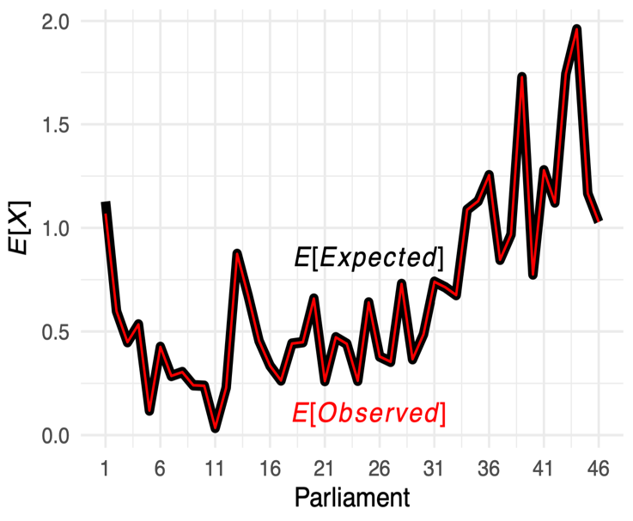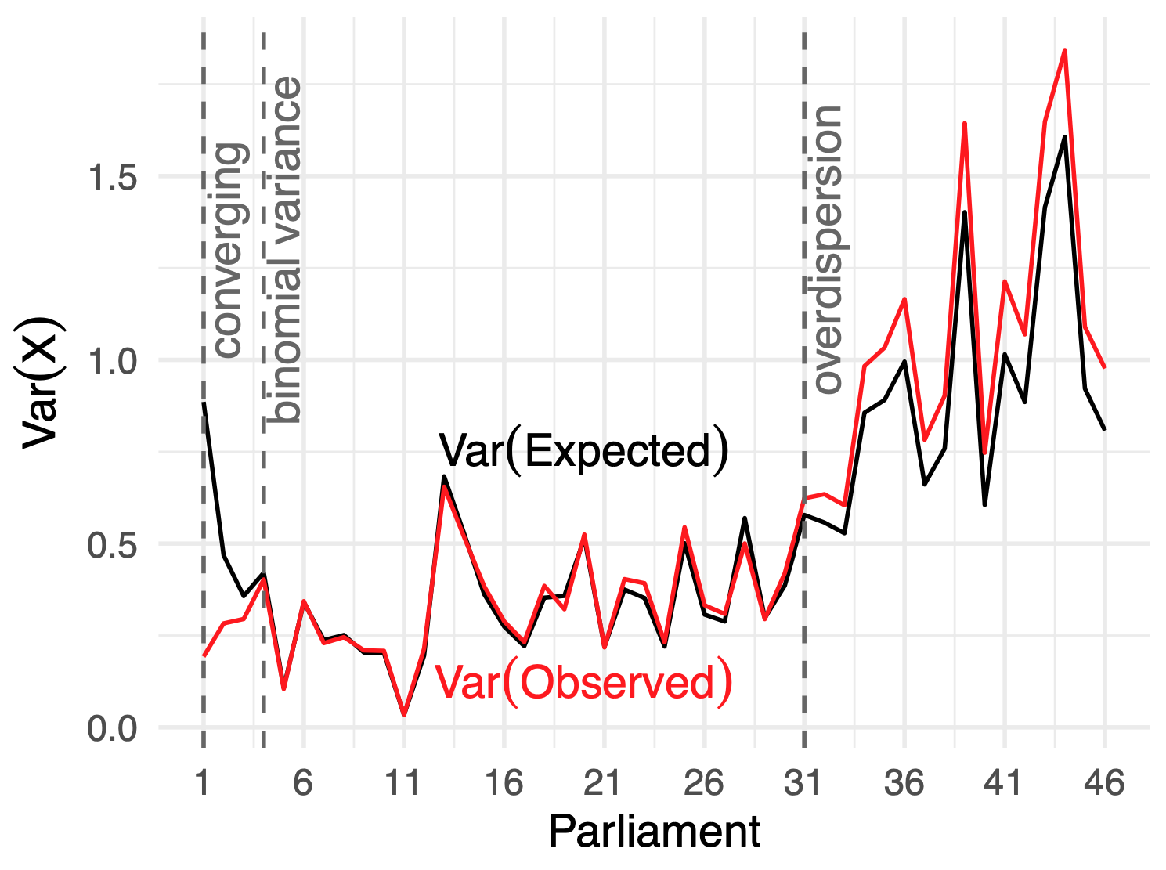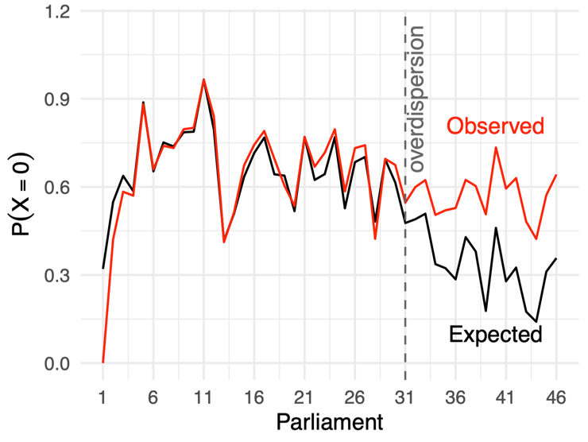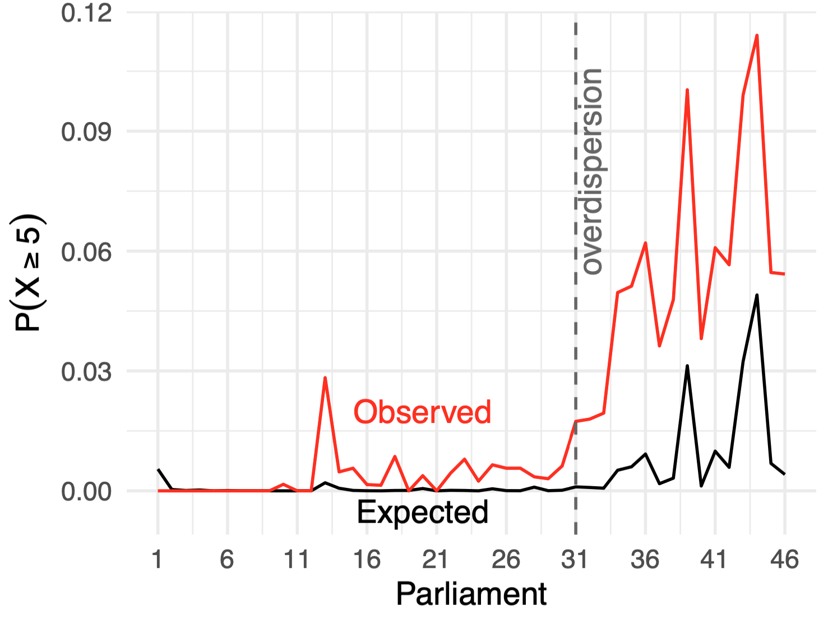

Figure 1: Assessing the fit of the binomial distribution for Acts of Parliament in Australia, 1901-2022.

Figure 2: Expected and observed proportions of acts with zero amendments or with five or more, 1901-2022

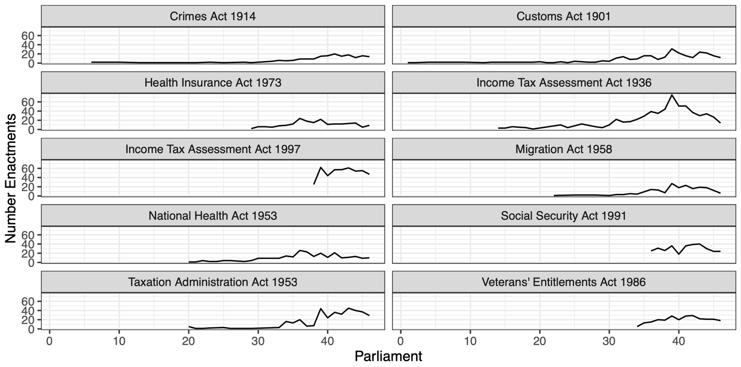

Figure 3: Ten most amended 'monster' acts, 1901-2022

1. Preamble to the *Financial Relief Act (1933)*